**SQL STOCK MARKET PROJECT**

#Describe table google

SELECT * FROM fly.goog;

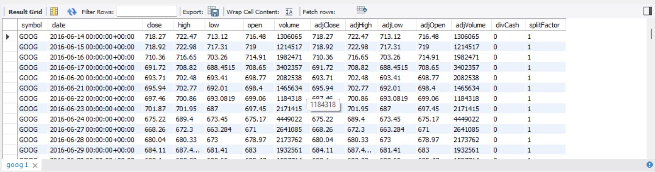

##subquery##

#select second lowest google stock value for that day

select * from fly.goog where low =(select max(low) from fly.goog where open<>(select max(low) from fly.goog));

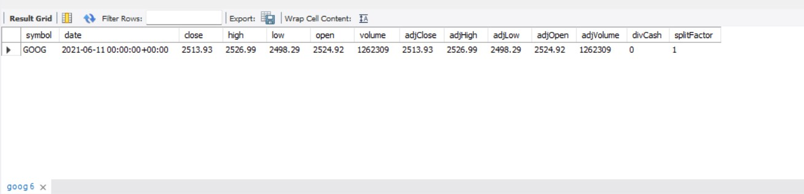

#highest value of google stock at that day

select * from fly.goog where high =(select max(high) from fly.goog);

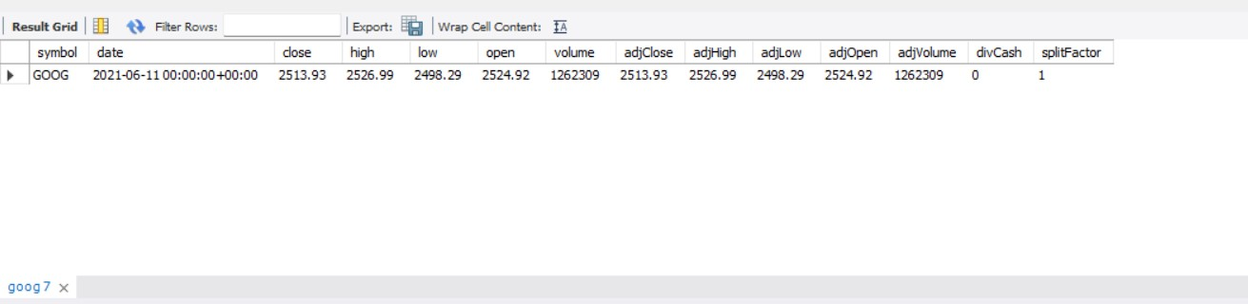

#closing of google stock for that day

select * from fly.goog where close=(select min(close) from fly.goog where close=(select min(close) from fly.goog));

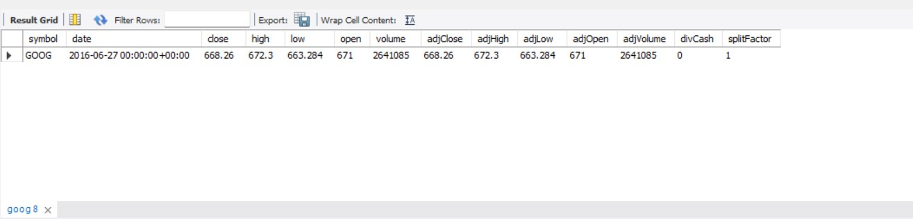

#Total number of high share of google are in action.

select * from fly.goog where volume>(select volume from fly.goog where high=689.4);

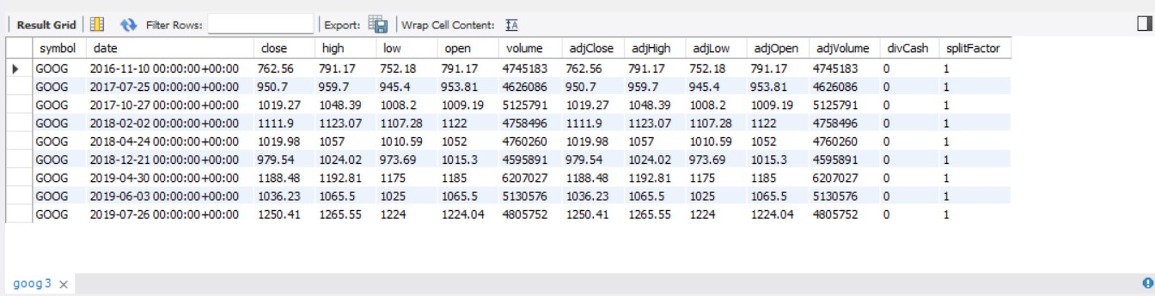

##join##

#Describe table bank

SELECT * FROM fly.bank;

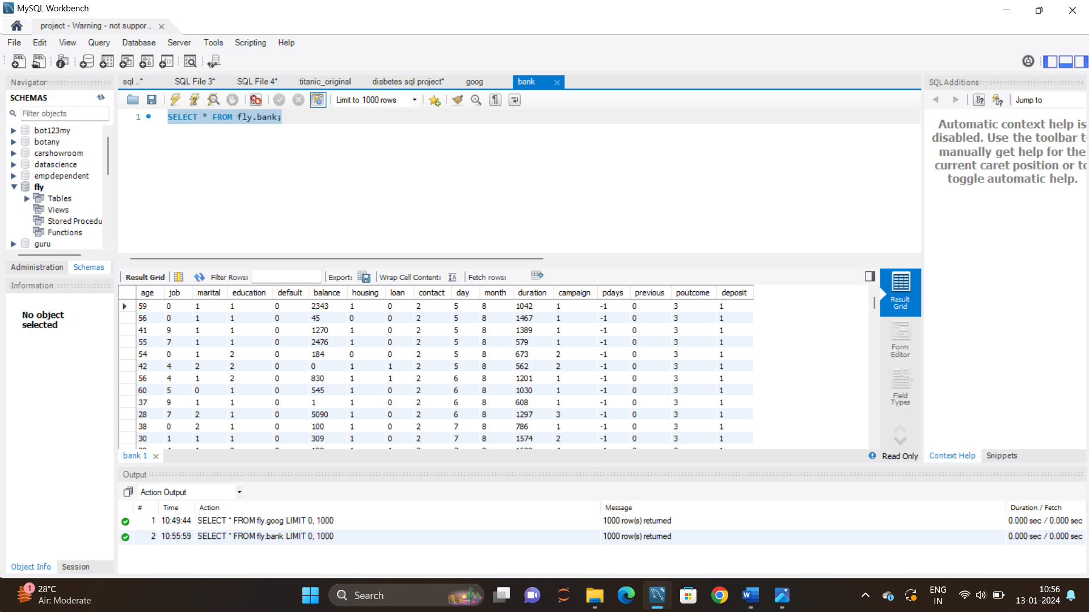

#Inner join

select fly.goog.volume as goog_volume,fly.bank.day as bank_day

from fly.goog

inner join fly.bank

on fly.goog.high = fly.bank.balance;

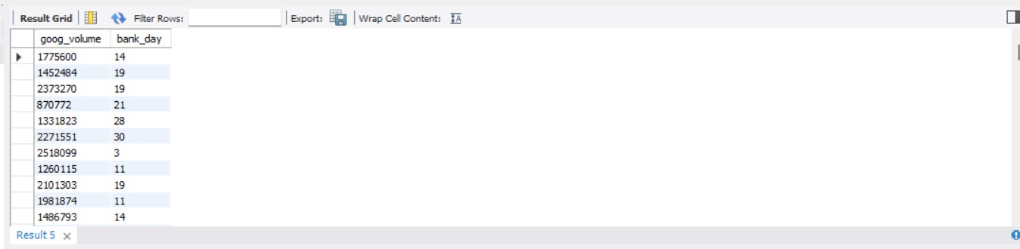

#Left join

select fly.goog.open as goog_open,fly.bank.month as bank_month

from fly.goog

left join fly.bank

on fly.goog.high = fly.bank.balance;

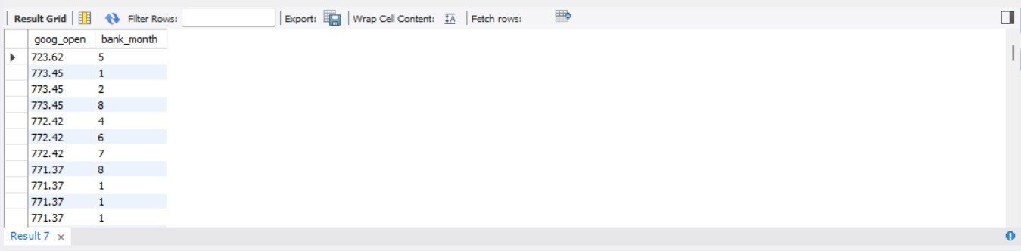

#Right join

select fly.bank.age as bank_age ,fly.goog.low as goog_low

from fly.bank

right join fly.goog

on fly.bank.balance =fly.goog.high;

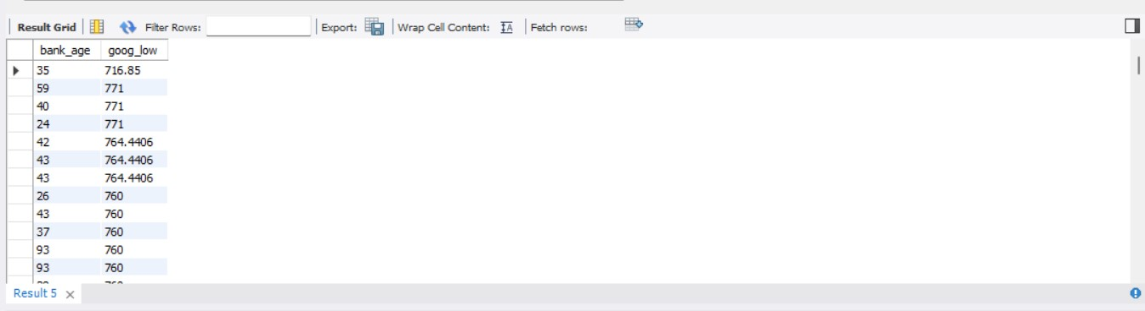

#Union of left and right join

select fly.goog.open as goog_open,fly.bank.month as bank_month

from fly.goog

left join fly.bank

on fly.goog.high = fly.bank.balance

union

select fly.bank.age as bank_age ,fly.goog.low as goog_low

from fly.bank

right join fly.goog

on fly.bank.balance =fly.goog.high;

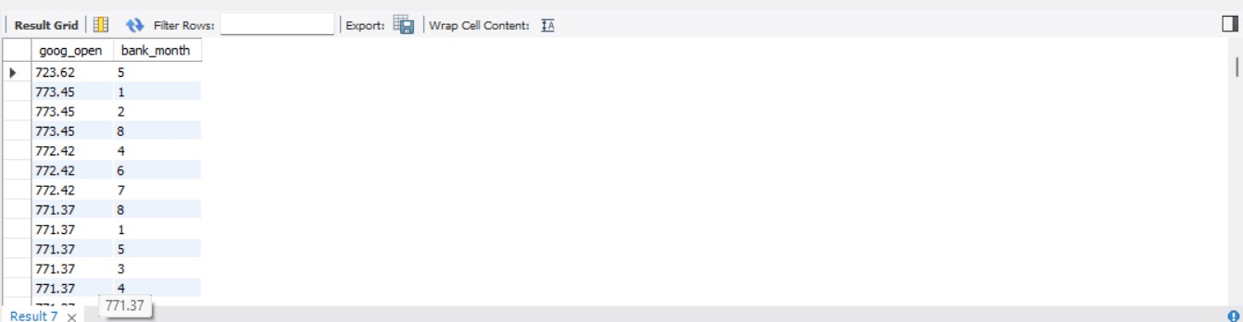

#Cross join

select fly.bank.age as bank_age ,fly.goog.volume as goog_volume

from fly.bank

cross join fly.goog

on fly.bank.balance =fly.goog.high;

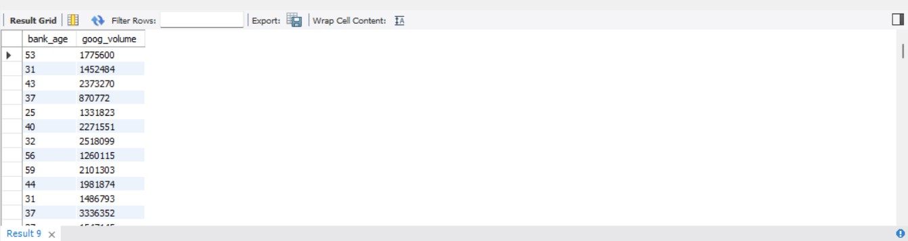

S